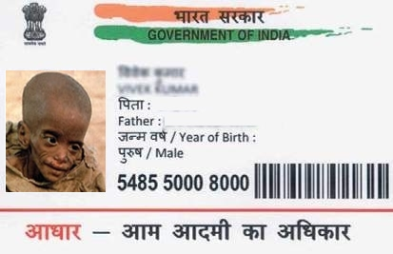

Anjali

Father name: ram

Dob: 5\2\2005

Female

0014 6542 2476